**SCREENSHOT:**

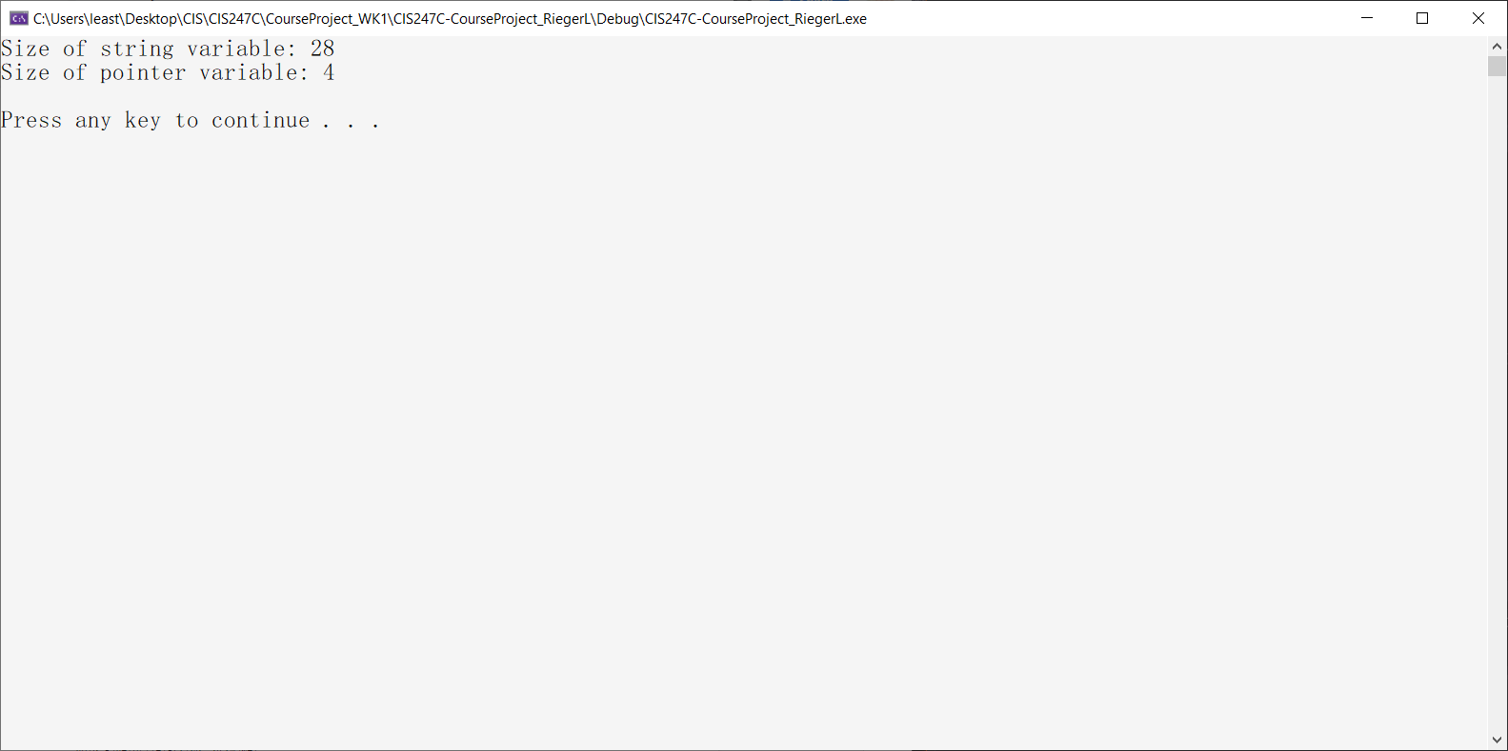

**CODE:**

/*

Leah Rieger

11/04/2019

CIS247C Course Project

*/

#include <iostream>

#include <string>

#include <iomanip> // setw, setprecision

#include <fstream> // required to read/write to files

using namespace std;

//prototypes

void saveToFile(string* ptrName);

// entry point for the application

int main()

{

// create string variable & pointer to string

string name = "Leah Rieger";

string* ptrName = &name;

// check the size

cout << "Size of string variable: " << sizeof(name) << endl;

cout << "Size of pointer variable: " << sizeof(ptrName) << endl;

// pause

cout << endl;

system("pause");

return 0;

}

void saveToFile(string* ptrName)

{

// open the pipe to the file

ofstream outToFile("data.txt");

// if the file is open, write data to file

if (outToFile.is_open())

{

outToFile << *ptrName << endl; // notice that we dereference the pointer!

//close the pipe

outToFile.close();

//tell user that the data was written

cout << "\nData was written to the file!" << endl;

}

}